Shabbos Stories For
Parshas ki sisa 5786
Volume 17, Issue 26 18 Shevat/March 7, 2026
Printed L’illuy nishmas Nechama bas R’ Noach, a”h

The Miraculous Eyeglasses
From the Desk of Yerachmiel Tilles

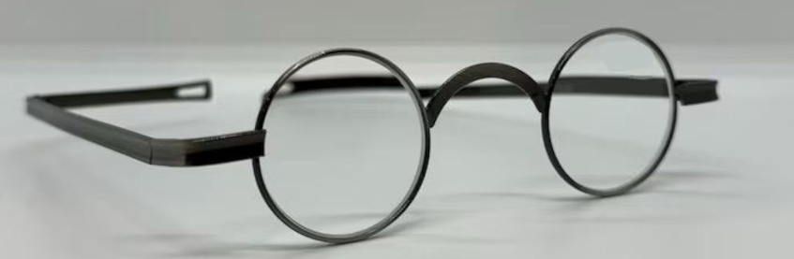

Around 200 years ago, in the city of Lemberg in Galicia, a baby boy was born into a Jewish family with the last name Brill. According to legend their name was derived from the "brillen" (‘glasses’ in Yiddish) at the heart of this story. The parents’ joy was short- lived, however, when it was discovered that the child was blind. As the doctors could do nothing to help, the parents accepted the Divine decree and loved their child even more.
The boy's first name is not known, but for our purposes we will call him Micha. When Micha was three years old he was given his first haircut and brought to school. Although he obviously could not learn to read, the teacher began to teach him the blessings and prayers by heart. It soon became apparent that the child was unusually intelligent. Whatever he heard was immediately remembered.
Over the next 'few years he memorized the entire prayer book, many books of the Bible and many tractates of Mishna. The child acquired a vast amount of Torah knowledge and was beloved by all. Micha was especially drawn to sefarim, Jewish holy books. Even though he couldn't read, he would remove them from their shelves and lovingly caress their pages. Passing his fingers over the holy letters, he seemed to absorb their sanctity. Each book received a kiss before being put back.
One time Micha asked his brother to bring him to the main study hall in Lemberg. As was his habit, he began to take the sefarim off the shelves and straighten out their pages. He came across a very thick volume covered with dust; it was obvious that no one had used it in a very long time. He opened it and was surprised to feel something hard between the pages. It was a glasses case that someone had forgotten.
The boy opened the case, took out the glasses, and playfully put them on. He thought he would faint: unbelievably, he could see! The entire world suddenly came into focus. Micha thought he must be dreaming. He took off the glasses and again was blind. Putting them back on, he could see his younger brother and the square-shaped letters on the pages before him. It was a miracle. Micha fought against the urge to cry out about what had happened. But he was still in shock and needed a little more time to assimilate the change.
Instead, he put the glasses in his pocket and asked his brother to take him home. Micha 's parents could see that something was wrong. The poor boy's hands were trembling; he was deathly pale and could barely eat. But when they asked him what was the matter, he insisted that everything was fine. That night he waited until everyone had gone to sleep to try on the glasses. Again, he could see as if he had never been blind!
A few days later he could no longer keep the secret to himself, and told his parents about the miraculous glasses. Needless to say, the entire household was filled with gladness and light. Soon, the whole city of Lemberg marveled at the miracle. Everyone agreed that there was no one more deserving of such good fortune than he. Moreover, now Micha could begin studying Torah in earnest.
Sometime later Micha went back to the study hall to take a good look at the book in which he had discovered the glasses. It was an ancient volume of Kabala (mysticism), and although he had made great strides in his studies, he could not understand much of what was written. Micha was determined to learn more about the book and the glasses, but no one was able to answer his questions.
Finally, he found a very old man who remembered that as a young child, he had often seen the Rabbi of the town poring over that particular volume and wearing similar glasses. Further questioning revealed that the rabbi was none other than the famous Torah scholar known as the "Pnei Yehoshua" for his celebrated commentary on the Talmud.
Astoundingly, Micha later learned that he had found the glasses on the exact date of the rabbi's passing, the 14th of the Jewish month of Sh’vat! For the rest of his life, he observed the Pnei Yehoshua’s yahrzeit as a special day of thanksgiving. Micha Brill grew up to be not only a Torah scholar but also a successful businessman who gave generously to charity.
Years later, when he passed away after a long and fruitful life, his many descendants gathered to divide up their inheritance. Everyone was willing to relinquish everything their father/grandfather had left them in exchange for the miraculous glasses. In the course of their argument the glasses fell to the floor and shattered, and so each of his children ended up with nothing but a small sliver of glass.
Source: Modified by Yerachmiel Tilles from an old issue of “L'Chaim,” a weekly publication of the Lubavitch Youth Organization. Why This Week? In this week’s Torah reading, Yitro, which details the five days before G-d declaring the Ten Commandments, in verse 19:11[+ Rashi] we learn that all the blind were cured.
Biographical Note: Rabbi Yaakov-Yehoshua Falk [1680 – 14 Shvat 1756] was an early 18th-century scholar and rabbinic authority, known for his widely-studied and celebrated Talmud commentary, Pnei Yehoshua, which largely focused on resolving questions posed by Tosafot on Rashi. He served as lead rabbi in several communities, including Lemberg, Berlin, Metz, and Frankfurt. [based on Sefaria.]

Reprinted from the Parshat Yitro 5786 email of KabbalaOnlineorg, a project of Ascent of Safed in Israel.
Overcoming One’s Pain

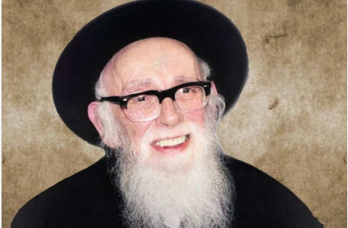

The Rebbetzin of Rav Shlomo Zalmen Auerbach, zl, predeceased him. Their fabled marriage was a lesson in sholom bayis and the respect and admiration one should manifest for a spouse. Rav Shlomo Zalmen was in the hospital because his beloved Rebbetzin, his companion in life, with whom he had raised a generation of gedolei Yisrael, had just passed away.
One of his students (Rav Auerbach was Rosh Yeshivah of Yeshivah Kol Torah), totally unaware that his revered Rebbe had just been left bereft of his wife, met him in the hospital corridor. The student’s wife had just given birth to a child, and the joy on the young man’s face was palpable. He ran over to his Rebbe and cried out, “I just had a baby (boy (girl)!”
The aged Rosh Yeshivah and poseik ha’dor gave him a big smile and an enthusiastic, “Mazel Tov!” During his moment of pain, he was able to put his own sorrow on hold, because the young man needed a mazel tov! Now! He would not permit his personal anguish to put a damper on his student’s joy. His simcha warranted his Rebbe’s blessing, and he would receive it. Some exceptional people do not live for themselves, but rather, they live focusing on the needs and feelings of others.

Reprinted from the Parshas Yisro 5786 email of Peninim on the Torah, a publication of the Hebrew Academy of Cleveland as edited and compiled by Rabbi L. Scheinbaum.

The Son of the First Belzer Rebbe – the Sar Shalom

Reb Yehoshua Rokeach zt”l was the youngest son of the first Belzer Rebbbe, the Sar Shalom zt”l. Though it was common in that era to anoint a close disciple to take over the Rabbinic leadership after a Rebbe’s passing, the concept of hereditary rabbinical succession, with a son assuming the mantle after his father, was new.
Compared to his father, Reb Shalom, who traveled to meet and learn from great Chassidic leaders of the time, Reb Yehoshua, on the other hand, had yet to travel to any. He used to say, “My father was my only Rebbe, and he taught me everything and revealed all that will happen to me until I pass on. He never told me to travel to other Rebbes; therefore, I don’t.
The Mittler Rav was from the leading Rabbanim who combated the Maskilim - the enlightenment movement at the time. Together with Reb Shimon Sofer zt”l, the Krakov Rav, they established Machzikei Hadas to fight the maskilim and established Kol Machzikei Hadas - a religious newspaper to combat the rebellious papers.
The head of the Maskilim met in Lemberg with leading Rabbanim, with Reb Yehoshua presiding. The Maskilim proposed a treaty saying that the Maskilim and
Chassidim should agree on a middle way approach to Yiddishkeit since there’s no side route to Yiddishkeit; either to be completely removed from Torah or completely adhere to the ways of Chassidus.
Reb Yehoshua told the head of the Maskilim to come to the window and describe what he saw outside. He answered, “I see people walking on the sidewalks and horses in the middle of the road.” Reb Yehoshua replied with a smile: “Yes, yes! You said well. Only horses go the middle way!”

Reprinted from the Parshas Yisro 5786 email of The World of Belz.

Making the Doctor Believe

During his final year, Reb Yehoshua of Belz zt”l underwent surgery in Vienna. Before the surgery, Reb Yehoshua asked the doctor, a non-religious Jew, if he believed in Hashem. The doctor replied, yes. Reb Yehoshua continued asking, “Do you believe in Moshiach?” The doctor responded, “No, since it says that Moshiach will be a pauper riding on a donkey, how will a poor person scare the other nations?”
Reb Yehoshua lifted his long eyebrows and fixed his holy eyes on the doctor. The doctor became so frightened that the surgical knife dropped from his hand. Reb Yehoshua explained to him, “If I, a simple person, can startle you so, then Moshiach will surely cause a panic across the world.”
The doctor became a baal teshuvah and escorted the Rebbe back to Belz by train. Midway, Reb Yehoshua said Shema and was niftar. (The doctor merited to be the tenth person in the minyan as the Rebbe’s neshama departed this world.

Reprinted from the Parshas Yisro 5786 email of The World of Belz.

A Most Unusual
Shailah (Question)

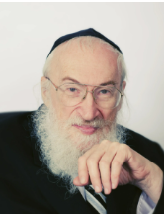
Rav Chaim Yisroel Belsky, zt”l

The Gaon and Posek Hador, R’ Chaim Yisroel Belsky zt”l was often described as a “multifaceted genius” because he possessed a rare grasp of literally kol haTorah kuloh, as well as every facet of the natural world. His truly dazzling intellect gave him the unique ability to bridge abstract Talmudic theory and concrete physical reality. His time, though, was limited, and he often bemoaned the fact that he could not assist more people.
He once told a talmid, “They think they’re helping me by shutting my phones off, but they are really killing me! They make it much harder for people with questions to reach me. What else am I here for if not to answer people’s questions and help them with shver sugyos (difficult topics) in Torah?!”
The following story was told over by the current Rosh Yeshivah of Torah Vodaath, R’ Yisroel Reisman shlita. A kollel fellow in Eretz Yisroel stumbled upon a very difficult, obscure shailah (halachic question). It wasn’t a standard question about milk and meat or Shabbos times; it was a complex reality that didn’t seem to have a clear precedent.
Troubled by the issue, he went to his kollel in Jerusalem and approached the Rosh Kollel, a man of significant learning, and laid out the complexities of the case. The Rosh Kollel furrowed his brow and said, “Ah, a geshmake shailah! I have truly never heard such a scenario before. I cannot answer you on the spot, I need to be meiyen (delve deep) into the sugya. Give me some time.”
The young man waited, but his anxiety grew. That evening, he approached his local Rav, a seasoned community posek, yet the Rav’s reaction was identical. “What a difficult shailah,” he remarked, shaking his head. “I cannot give you a ruling yet. Come back tomorrow.”
On his way home, he asked a third Talmid Chacham but he too, had no clue how to pasken. When he returned home that night, his wife asked, “Nu? Did you get an answer?” The man shook his head disappointedly. “Nobody knows the answer. They all need time to research it.”
She looked at him for a moment and then said, “Why don't you just pick up the phone and call Rav Belsky? You know him from when you lived in Brooklyn, correct?”
The young man hesitated. Rav Belsky was one of the greatest Poskim in America, a Rosh Yeshivah at Torah Vodaath, and a senior decisor for OU Kosher. He was surely overwhelmed with major communal issues. Was it right to bother him with a personal call from across the ocean? He thought about it for a moment and then, mustering his courage, dialed the number.
The phone rang, and to his surprise, Rav Belsky himself picked up the phone. The young man, a bit baffled by the unexpected voice on the other line, stammered for a bit but the Rav calmed him down. Soon, he was able to lay out the complex details of his unusual query. He waited for the silence, expecting Rav Belsky to also say he needed time to think.
Instead, Rav Belsky gave a warm laugh and told him, “You know, it is such an unusual shailah, I haven’t heard it in years ... and yet, you are the fourth person to call me with this exact question since yesterday!”
He then launched into a complicated but clear treatise, emerging shortly with a decisive ruling on the spot! R’ Yisroel Reisman concluded: “There are so many amazing things to take out of this story - it isn’t just that Rav Belsky knew the answer or that all four Rabbonim knew who to call in time of need. Rather that all of them got through to him!

Reprinted from the Parshas Yisro 5786 edition of Rabbi Dovid Hoffmn’s Torah Tavlin.

Guess Who I Prank Called
Moshe Gelber

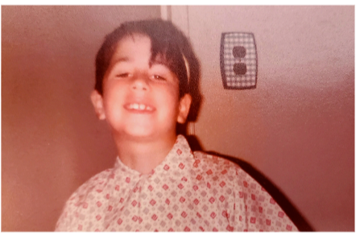
Moshe Gelber in the early 1980s

I used to love coming to 770 as a young boy whenever the Rebbe held a late-night farbrengen, because it meant that I could stay up instead of going to bed on time. I knew the Rebbe was a great man, but I was a naive kid and didn’t really understand all of the things he was saying. So, while he would be delivering these groundbreaking talks about how we have to better our lives, I would be sitting under the bleachers with my cousins, tying people’s shoelaces together.
It was the 1970s, and although I was growing up in Flatbush, I attended the Lubavitcher Yeshiva in Crown Heights: My uncle, Dr. Moshe Feldman, served as a physician for the Lubavitch community and he influenced my parents to send me to that yeshivah. I would also get in trouble there, because I was a troublemaker.
My antics were mostly harmless practical jokes, which I did because I was trying to be funny, not to hurt anybody. They used to tell stories about a man named Reb Hershel of Ostropol, who was like the jester in the chasidic court of Rabbi Boruch of Mezhibuzh, and I think every generation has its pranksters. So, I was just carrying on that tradition.
One of the ways my cousins and I would be mischievous was by making prank calls. One day in the early ‘80s, when I was eleven, we were playing in my uncle’s office, and saw a note. It said “Schneerson, 1304 President Street,” and underneath that was a phone number.
We looked at each other. “Schneerson... that’s the Rebbe’s house!”
Then my cousin gave me another look. He wasn’t as mischievous as I was, but he was a good instigator. “I dare you to call it.” I called the number. A sweet old woman answered the phone – and I got scared. Instead of saying anything, I just made some animal noises, mooing like a cow for a few seconds, and then I hung up the phone. Five minutes later, I did it again, although this time I made some goat sounds.
About six months later, it was Sukkot, in the intermediate days of the festival, and I was back at my uncle’s house. Our family was getting ready to have lunch together, so they were all outside in the sukkah when I was sent back into the house for some napkins and cups.

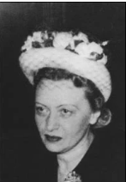
Rebbetzin Chaya Mushka Dr. Moshe Feldman

When I went back into the house, the red phone was ringing: Aside from the regular house phone, my uncle had a red phone reserved for medical emergencies. Only a few people in the community had the number for the red phone, and we children were instructed to never play with it, or even to touch it. But since it was ringing and no one else was in the house, I decided to answer it. I also decided to answer it like an idiot: “Helloooooo, who is it?” I inquired, in a ridiculous, high-pitched voice. The woman on the other end was slightly taken aback. “I’m sorry,” she said. “I must have called the wrong number. I’m trying to reach Dr. Feldman.”
“But this is Dr. Feldman’s house,” I replied. “He’s just outside, in the sukkah, and I can go get him for you. Who’s calling please?”
“This is Mrs. Schneerson from President Street,” she said. “Okay, hold on a minute.”
I went to my uncle and told him who was on the phone, and he ran into the house. A minute later, he came back out.
“How dare you?” he fumed. “I’ve told you so many times not to ever play games on the red phone. If somebody is calling that phone, it could be a life-threatening emergency and you could be delaying their medical care with your jokes. Do you know who was on the phone now?”
“Mrs. Schneerson from President Street?”
“Don’t be a wise guy! That was the Rebbetzin! She’s not feeling well and she asked me to come over. Now get your coat because you’re coming along. She wants to meet you.”
I was terrified. As we began walking, my uncle added: “And how dare you make prank calls to her!”
How does he know about that?, I wondered, but I got my answer before I could ask. “The Rebbetzin recognized your voice! ‘That’s the little boy who called me a few months ago, once as a cow and another time as a goat,’ she said!”
I’m going to be punished in ways I don’t even comprehend, I thought. When we got to the Rebbe’s house, the door was unlocked. My uncle just turned the knob, we walked inside, and he started going up the staircase to the right, before turning back to me. “You stay right over there,” he warned. “Don’t touch anything!” As he walked up, the Rebbetzin appeared at the top of the staircase. She looked down, smiled at me, and waved. I waved back, and she disappeared back into a room, with my uncle behind her. That’s it? I wondered. She just wanted to wave? That’s not so bad.
Then, I felt a tap on my shoulder. I turned around to see a man standing there with a stern look in his eye. His name was Gansburg, as I later found out, and he worked as an assistant in the Rebbe’s house. “Are you Moshe?” he queried.
“Yes.” A sense of dread came over me: He must be the executioner.
“Come with me, please.” Shalom Ber Gansburg led me though the living room, into the kitchen, past the bright orange and yellow floral trim on top of the kitchen wallpaper, and through a door at the back of the kitchen. The door led directly into a sukkah, where a table was set.
“The Rebbetzin prepared lunch for you,” he informed me. “Please sit down and enjoy.”
There were two challah rolls, salad, a piece of baked salmon, and a cup of orange juice – already poured and ready to drink. I still remember how delicious it all was. As I sat there and ate, I mused about this unexpected turn of events. I thought I was going to be severely punished for my little joke, and now I had been invited into the Rebbe’s private sukkah, to eat a meal that the Rebbetzin had prepared! I don’t know of anyone else in the community who had ever received such an honor. I’m going to brag to all of my friends about this, I gloated inside. I’m the man!
But the moral of the story is about the character of the Rebbetzin. I was mischievous, but she saw the bigger picture and knew that I really wasn’t a bad kid; I was just trying to be funny. I think she had a sense of humor about it too. So even though she wasn’t feeling well, she went out of her way to make sure I had a nice lunch to eat. Looking back, I’m still inspired by the act of kindness and love that the Rebbetzin showed me so many years ago. She was a great woman and she loved all of us, like a grandmother loves her grandkids even when they make trouble. Maybe that is how G-d loves all of us, even though at times we don’t do what we’re supposed to.
______________
Mr. Moshe Gelber is a street photographer and audio-systems engineer. He was interviewed in November 2015.

Reprinted from the Parshas Yisro 5786 edition of Here’s My Story [with the Lubavitcher Rebbe.] a project of JEW (Jewish Educational Media.)

How Shabbat
Came to Greenland
By Sofya Sara Esther Tamarkin

Our journey to board a cruise ship to Greenland started in Iceland's capital, Reykjavik, which welcomed us with such strong winds that it was hard to keep both feet on the ground.
Together with another couple, my husband and I had traveled from Philadelphia to this cold and exotic destination. We had a few hours before we were set to board the ship, so we made our way to the Chabad House in Iceland’s capital, directed by Rabbi Avraham and Mushky Feldman.
The small Jewish community in Iceland welcomed the Chabad couple in 2018, and in the short time since, thousands of tourists and locals have benefited from Jewish public celebrations, kosher catering, and Torah classes.
The four of us were greeted with hot tea and a warm welcome. We had a few hours to spare, and my friend Anna and I decided to join Mushky’s weekly Torah class for women. Sitting with a group of women from very different walks of life, who had ended up in this remote place for an encounter with Chassidic, timeless wisdom, was incredibly inspiring—a memorable and warm start to our ten-day journey into the cold waters of Greenland.



I had done my research and emailed many departments to confirm in writing that kosher food would be available for us on the cruise, so when the chef came out to ask if we had any special dietary needs, we were frustrated to say the least.
The ship was sailing away from the shores of Iceland, with Chabad catering options getting further away by the minute. It was clear that we were going to be eating lots of fruits and vegetables for the next ten days.
Little did we know that this dietary emergency would become the gateway to a spiritual transformation.
The story really begins years earlier. During the pandemic, my maternal aunt passed away from Covid. I was then taking many online Torah classes. Soon after, I received a gift in the mail: pop-up flowers with a note of condolences and genuine words of love and support from one of the fellow students in that class. Interestingly, she did not sign her name but instead ended her message with two words: “soul sister.” I remember being touched to tears and immediately placed the flowers near my siddur so I could stand next to them in prayer every morning.
Now, five years later, with that same prayerbook on board the ship, we stood in the cafeteria near an apologetic chef who was willing to cook kosher but had no idea how. As we politely explained that kosher food cannot be easily prepared without a thorough understanding of Jewish laws and certain supplies, another visibly Orthodox couple approached and joined the conversation. Since kosher food couldn’t miraculously appear on the board of the ship, there was no point in arguing.
The next day, I went to a small gym on the boat. There were two more women there exercising on treadmills. I was on a machine on the left, and the other woman who had been promised kosher food was on the last treadmill on the right. With one woman in between us, I did not feel comfortable having private conversations about kosher food solutions, and so after I was done exercising, I walked up to her machine to strike up a conversation.

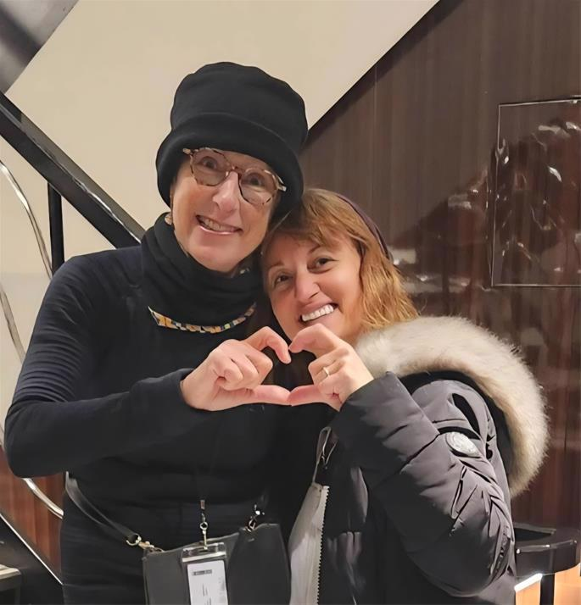
Kim (left) and the writer – Sofya Sara Esther Tamarkin

I was immediately greeted with a warm southern smile, as Kim adamantly reassured me that my name sounded familiar. Since our last names were mentioned over and over again when the chef and his crew tried to locate kosher meals, Kim had been trying to figure out where she could have met me before. We began to list possible ideas, including online classes. Finally, we discovered that we had taken the same life coaching class for years and heard each other's names during the sessions as participants shared their perspectives. As we continued to chat, Kim asked which ideas I connected to the most, and I shared that it wasn’t the information that made the most impact but the kindness of a fellow participant who found my address and sent me a gift of support during a very challenging time.

Kim opened her phone and pointed to my home address. I still didn’t understand what she was saying.
“It was me who sent you those flowers.”
I froze in astonishment. How could this possibly happen?
The woman on the treadmill—who introduced herself as Karen—witnessed our statistically improbable encounter and was as completely blown away as I was. To add to this miraculous afternoon, she turned out to be Israeli.
Karen shared this miraculous encounter with other passengers. There were about 160 passengers on board, and surprisingly, about a quarter of them were Jewish.
This meeting infused me with a sense of purpose—there was clearly a Master Plan at play here. I felt compelled to align with that Higher purpose.
Sailing through the wilderness of Greenland with breathtaking scenery all around us as Shabbat approached, fellow passengers who were impressed by our story of Divine Providence approached Kim and me to inquire about lighting Shabbat candles.

Calculating the correct time for lighting candles had required lots of research and input from rabbis who understood the complexity that arises in a part of the world where the sun rarely sets.
Now, our dramatic reunion had catapulted us into the position to share Shabbat with our fellow passengers. People gathered around as we lit as many candles as we could gather. We said a prayer together, and my husband, Sasha, made Kiddush. Miraculously, there were bottles of kosher wine on board. How and why they got there is a mystery.
We then settled in for a Friday evening of sharing stories of our shared heritage. Other passengers joined in. We were one big Jewish family who had come together on this holy day. One of the passengers, a medical doctor, shared his thoughts: “A couple dozen Jews on a small expedition ship in the Arctic Circle gathering to say prayers, light candles, and break bread on a Friday night, led by a charismatic and energetic woman who brought smiles and stories, were able to transform a small corner of the dining room and remind everyone that we’re all connected and tasked with bringing G-d’s light to the world. It’s what we’re called to do.”
That Shabbat laid a foundation of lifelong friendships. Throughout the week, travelers shared ideas about spirituality, faith, and connection to the Creator. With the majestic Arctic sun behind huge, magnificent icebergs floating nearby, spiritual ideas felt real and viable.

During our stop in Nuuk, the capital of Greenland, many visited a local store and bought tea light candles to use that coming Friday night. By the time we were ready for our second Shabbat on board, we felt an undeniable connection. As old friends, we gathered in the cafeteria to welcome our holy day.
Earlier, my husband had asked the Guest Services to make an announcement: “Jewish passengers are invited to welcome Shabbat and hear Kiddush in the cafeteria at …” It was also printed in the daily program brochure.
It felt like a taste of living in Messianic times to have everyone enthusiastically helping us welcome Shabbat.

Another passenger, also named Karen, whose husband hadn’t participated in any Jewish observances since 1968, shared her experience: “I don’t know how we found each other, but we felt honored and welcomed by sharing Shabbat. It’s a testament to having an open heart and mind and the valuable experiences that await.”
Kim, my forever profound “soul sister,” reflects on our reconnection, “Life is an adventure of growth. Every day we need to wake up with a thought of awe and curiosity, asking, ‘What does G-d have ahead for me today?’ ” We stay in touch almost every day.
Every week I send “Shabbat shalom” messages to the incredible people I met on that ship.

Our trip to Greenland taught me a few very important lessons. First, never underestimate a small act of kindness. The ripple effect of Kim’s action created infinite consequences. Second, nothing is too difficult for the Creator of the World, and the most statistically impossible events can become reality. And finally, together with other fellow passengers, we have witnessed that spirituality and connection can be found in every corner of the world. There is no place void of potential, and it is always up to us to reveal it, one moment at a time.

Reprinted from the Chabad.Org website.

